Plan for the next Sicily Online Judge (SOJ)
- What is it?
SOJ is an Online Judge built by SYSU IL team.
- What are the features? (Order by descendant priority)
  - External OJ submitter/crawler
  - Achievement system
  - Extendable sub-system(Sicily Chan^_^)
  - Multiple queued judges support
  - Manageable external script invoking
- Architecture
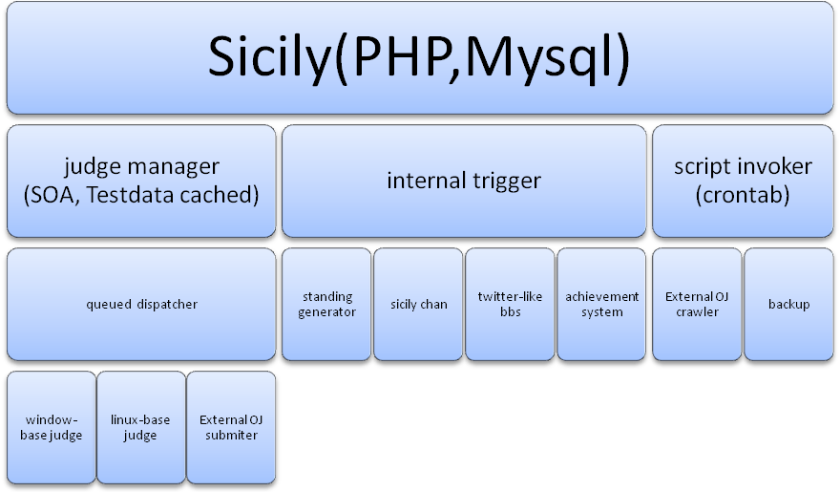
- What techniques are planned to use?
  - Web
    - PHP: Main language to construct the system. Easy to learn, lightweight than Java, rich optimizers/containers tuned for PHP
    - Jquery: Aid to construct UI.
    - XML-RPC: Communication with Judge
    - Codeigniter: PHP-Framework to aid reducing effort of coding
    - Mysql: No need to say, right?
  - Judge
    - C/C++/Java/python: free to use anything , as long as correctly implement the interface
  - External Submiter/Crawler
    - Python: Easy to learn
    - Pyquery: Aid to analyze html
- Why do we need to build such system?
  - Widely used in our school (CS, EE, SS, SYSUCPC, Weekly contests).
  - Benefit for our ACM team.
  - No open source project satisfies our need.
  - Funny entertainment for CSers.
  - Nice time-killer project, right? At least it’s better than DOTA.
- How much effort do we need to build it?
  - Although the old system is inefficient and hard to extend, it works, right? So we are planning to reconstruct part of the old system. Add interfaces for interacting with judge and the other sub-systems. This is the first part of our plan.
  - Completely rewrite the judge. Separate the manager and the actual judge(which including the executer and validater)
  - Construct the new sub-system. All the sub-system can be developed separated.
- Who is supporting this project?
  - Mr. Guo
  - Some fund from SIST and SS.

